fMRI (Functional Magnetic Resonance Imaging)
When a brain region becomes active, it consumes more oxygen. The local blood flow increases to supply that oxygen. fMRI detects these oxygenation changes — known as the BOLD signal (Blood-Oxygen-Level-Dependent signal).
So, fMRI doesn’t measure electrical activity directly — it measures hemodynamic (blood-related) changes that reflect that activity.

The Challenge: Measuring the Living Human Brain
The human brain is a dense network of ~86 billion neurons, constantly generating electrical signals.
Each neuron communicates through:
- Action potentials (spikes): short, millisecond bursts that send information along axons.
- Synaptic activity: the electrical and chemical processes when neurons receive input from others.
To truly understand brain function, scientists ideally want to measure this electrical activity directly — how neurons fire, communicate, and form networks.

Using Blood as a Proxy for Brain Activity
When neurons fire, they use energy — mostly in the form of glucose and oxygen.
This energy is delivered by the blood supply.
So, wherever neurons become more active:
- Oxygen is consumed.
- The local brain region increases blood flow to compensate.
This process is called neurovascular coupling — the link between neural activity and changes in blood oxygenation.
Key Point:
Even though fMRI cannot detect neurons firing, it can detect changes in blood flow and oxygen levels, which are reliably tied to neuronal activity.

Physiological Basis of the BOLD Signal
To understand how fMRI measures brain activity, we need to connect neural activity to blood oxygen changes.
(a) Microscopic Level — What Neurons Do
- A neuron has a cell body (soma), dendrites (which receive input), and an axon (which sends signals).
- When neurons receive input, they trigger post-synaptic activity, leading to action potentials (spikes).
- These electrical and chemical processes consume oxygen and energy.
(b) Macroscopic Level — What fMRI Detects
- When neurons use more energy, the local blood vessels respond with a localized increase in blood flow that far exceeds the neurons’ actual oxygen demand.
- This local surge in oxygenated blood increases the MRI signal — the BOLD (Blood-Oxygen-Level-Dependent) signal.
- Thus, the BOLD signal reflects a secondary, delayed effect of neural activity — not the activity itself.

What Is an Action Potential or Neuron Spike?
An action potential (often called a spike) is a brief electrical impulse that travels along the neuron’s axon. It’s the fundamental way neurons communicate with each other — similar to sending an electrical signal down a wire.
- A neuron at rest maintains a negative charge inside relative to the outside (~–70 millivolts).
- When stimulated, the neuron’s membrane potential rapidly shifts — this is the action potential.
Analogy:
Think of it as a quick electrical “burst” — a message that a neuron sends to another neuron.
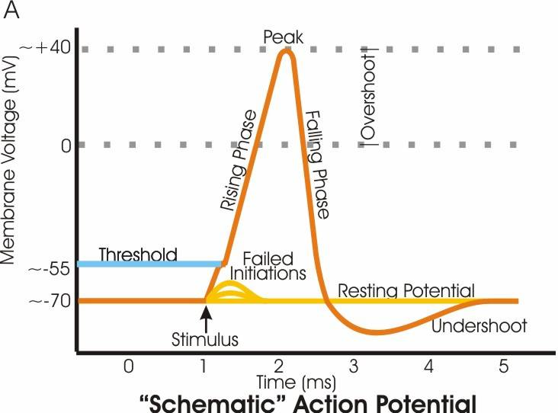

What Is LFP (Local Field Potential)?
The Local Field Potential (LFP) is the electrical signal generated by the combined activity of many nearby neurons — especially their inputs and synaptic processes, not just their spikes.

What is Firing Rate and Neural Coding?
- A single neuron can fire up to hundreds of spikes per second.
- The frequency (firing rate) and pattern of spikes carry information.
  - Faster firing → stronger signal or higher stimulus intensity.
  - Different firing patterns encode different sensory, motor, or cognitive information.
Example:
Visual neurons might fire faster when you see something bright and slower when it’s dim.

Why LFPs Matter?
LFPs provide a bridge between microscopic and macroscopic brain activity:
- Microscopic: they arise from local synaptic currents in a small patch of tissue.
- Macroscopic: their effects scale up to influence blood flow, which is what fMRI (BOLD) detects.
So, when neurons receive lots of input and process information, the LFP amplitude increases, and that region consumes more oxygen → leading to a stronger BOLD signal.

Why We Need the BOLD Signal ?
In Short, We can’t directly measure electrical activity (like spikes or local field potentials) inside a living human brain non-invasively. Electrodes can do that in animals or during brain surgery — but not for normal fMRI experiments.
So, we use an indirect measure: the BOLD signal.

How the BOLD Signal Works?
The BOLD signal (Blood-Oxygen-Level-Dependent signal) is based on the magnetic properties of hemoglobin:
- Oxygenated hemoglobin (HbO) is diamagnetic — it doesn’t distort the magnetic field.
- Deoxygenated hemoglobin (HbR) is paramagnetic — it weakens the magnetic field slightly.
When neural activity increases:
- Neurons use more oxygen.
- Blood vessels overcompensate by sending more oxygenated blood to that region.
- The relative amount of deoxygenated hemoglobin decreases, causing a stronger MRI signal.
That increase in MRI signal = the BOLD response.
It typically peaks 5–6 seconds after the neurons were active — that’s the hemodynamic delay.
Components of MRI and fMRI Analysis
The BOLD Image (Functional Image) :
The BOLD image represents changes in blood oxygenation over time, detected by functional MRI (fMRI).
Each BOLD image (or “volume”) is essentially a 3D map of brain activity at one time point. A full fMRI scan collects hundreds or thousands of these images — one every 1–2 seconds forming a 4D dataset (3D space + time).

Structural Image (Anatomical MRI) :
The structural image provides a high-resolution map of brain anatomy — the shape, size, and structure of gray and white matter.
It’s usually collected using T1-weighted MRI, which highlights anatomical detail, not function. This scan acts as a “reference frame” for aligning and interpreting functional data.
Why It’s Needed
fMRI’s functional data are lower resolution and somewhat distorted.
The structural image helps:
  - Correct for distortions.
  - Localize which anatomical region each functional voxel belongs to.
  - Normalize to a standard atlas.
In short:
The structural image tells us where things are;
The BOLD image tells us what they’re doing.

Atlas (Standard Brain Template):
A brain atlas is a standardized reference brain used to compare data across individuals.
Each person’s brain is unique, so we align (or “normalize”) everyone’s MRI data to a common coordinate system.

Surface–Volume Registration:
Surface–volume registration is the process of accurately aligning (or “mapping”) the 3D volumetric fMRI data onto the 2D cortical surface model of the brain.
It is used in fMRI to accurately align functional (BOLD) data with the brain’s folded cortical surface.
It maps 3D voxel data onto the 2D cortical sheet, improving localization of neural activity, reducing noise, and aligning brain folds (gyri and sulci) across individuals.
This process ensures that brain activity is analyzed and visualized where it truly occurs — on the cortex — rather than being blurred in 3D volume space.

